IMPULSE NOTES

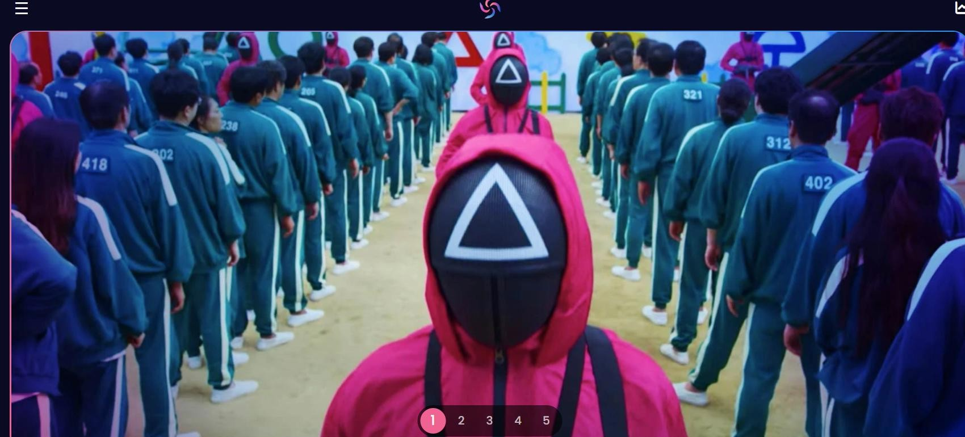
- We have to be able to change what comes up on the first page as a feature instead of it randomly featuring these products. How can we select and put what is in the selection pool.
- If it is a pay per view item it should be indicated on the page somewhere.


- These two button s take you to two different places. Why is that? Functionally are they the same thing or different,. If so how?

t
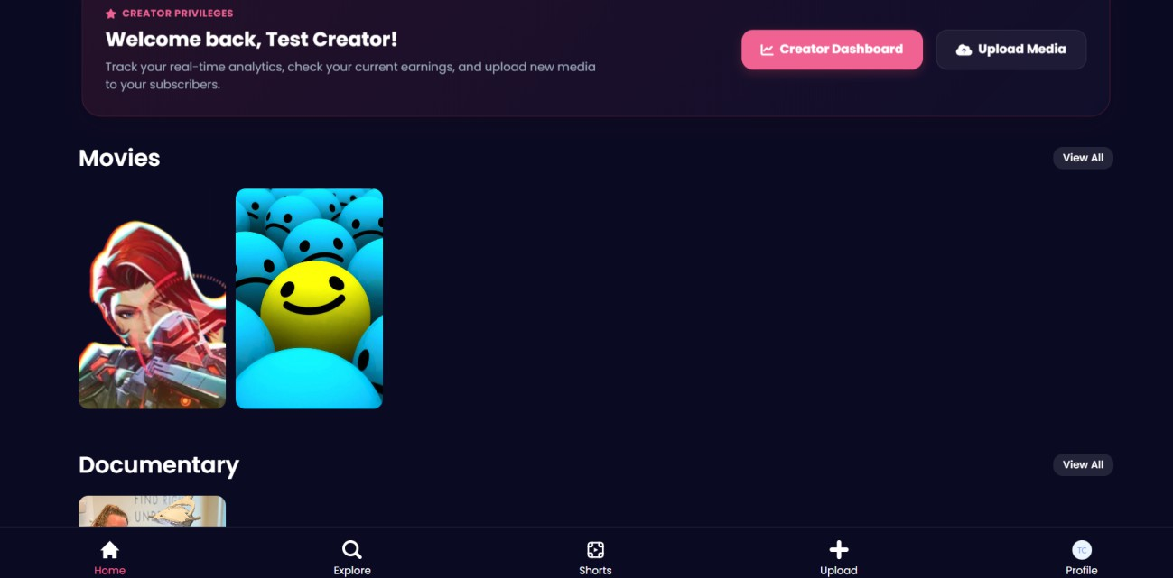

- Since we don’t have a lot of content instead of starting with movies it should start with
  - Popular (This should upload popular and new releases)
  - Pay Per view
  - Movies
  - TV shows
  - Documentaries.

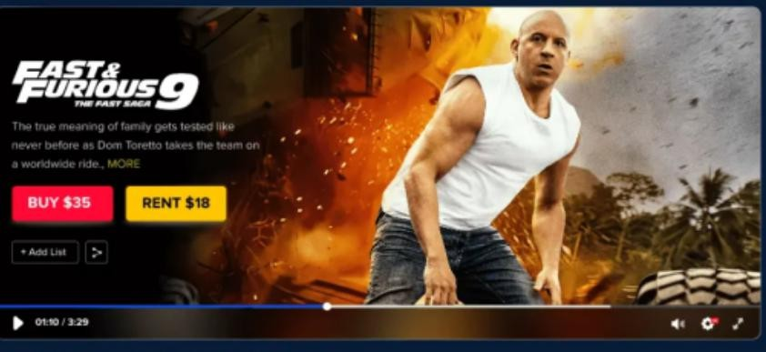

- We should have a trailer button and PPV button on all ppv content that is not free
- When playing trailer should only be no more than 60 seconds
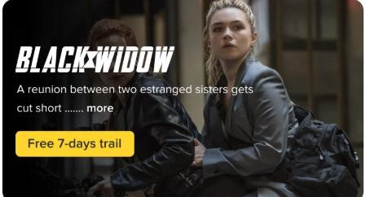
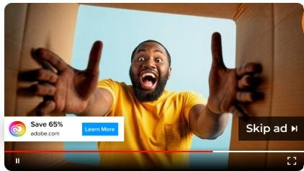

- Can we put in adds and also a skip adds button after 15 seconds?

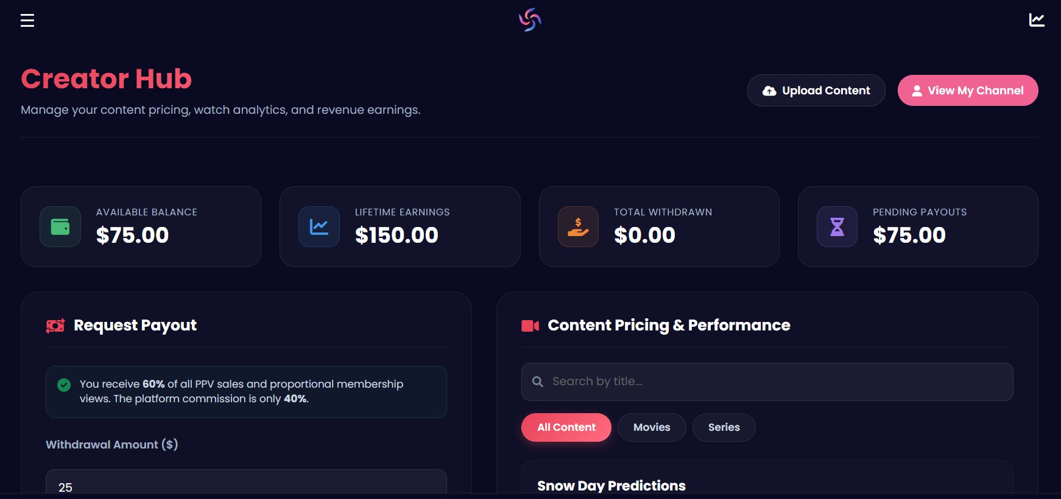

- Is this page active. If so:
  - How does the algorithm work to separate payouts to content creators
  - Do the checked items work and calculate automatically?
  - Where is this information stored?

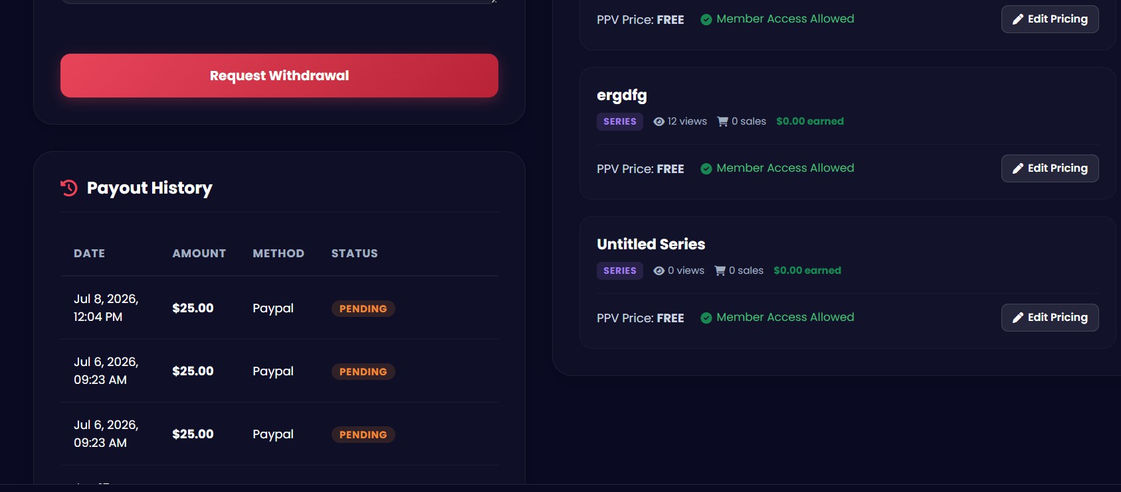





- Nothing happens when you pusht the request withdrawl button. ( is that a pay out withdrawal or withdrawal from the website.

- Does the pay out history work and is it automatically updated?
- When editing pricing does it now reflect the payment here and on the website? It didn’t work when I tried.
- When uploading content the trailer button should be optional. Right now it says optional but it is mandatory in order to upload content.
- Finally when signing on to the website we need an disclosure and acceptance page for terms and conditions page imbedded in with the end user liscence agreement that allows us to use and make money from the content being uploaded.

